

**USER GUIDE**

**RELEASE DATE : April 2017**

**Version 1.0**

**TABLE OF CONTENTS**

**Introduction…………………………………………………………………….3**

**Getting Started…………………………………………………………………3**

**Home Page……………………………………………………………………...3**

**About Page…….…………………………………………………………….....4**

**Sign Up Page….………………………………………………………………..4**

**User Preference Page.………………………………………………………..5**

**Login Page…….……………………………………………………………......5**

**Admin Page…….…………………………………………………………….....6**

**Add a New Source…….………………………………………………...…......6**

**Approve/Deny a Source…….…………….………………………………......7**

**Introduction**

Welcome to Sweet News! We are a website which allows you to select exactly what you want to see and then provide you with news articles from the most trusted sources (example AP, ABC, New York Times, etc) and therefore offer a wide selection of fact-checked news stories. This user manual provides a detailed description of all the features provided by Sweet News and helps in finding your way around the site.

**Getting Started**

Navigating to the Sweet News website for the first time will take you directly to the home page.

**Home Page**

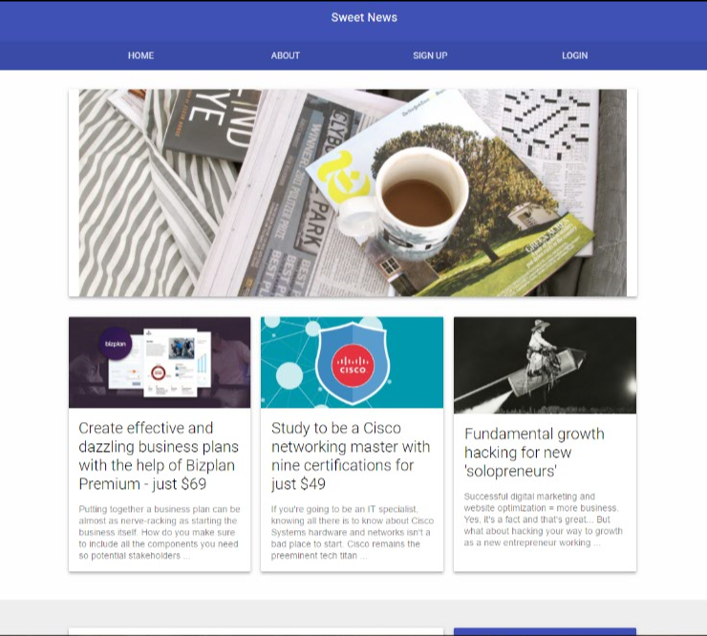

In the home page, you will be shown the recent major news articles by default. From this page you have the options to navigate to

* About
* Sign Up
* Login

**About Page**

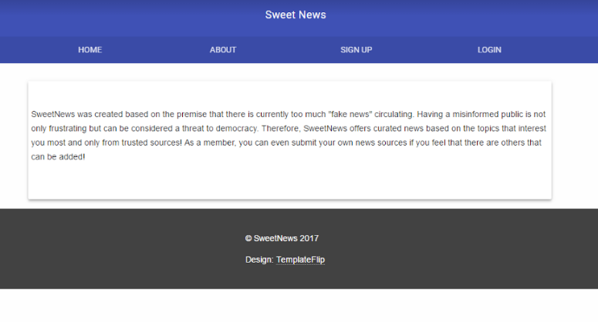

The About page contains general information about the website and provides a description of the site’s purpose.

**Sign Up Page**

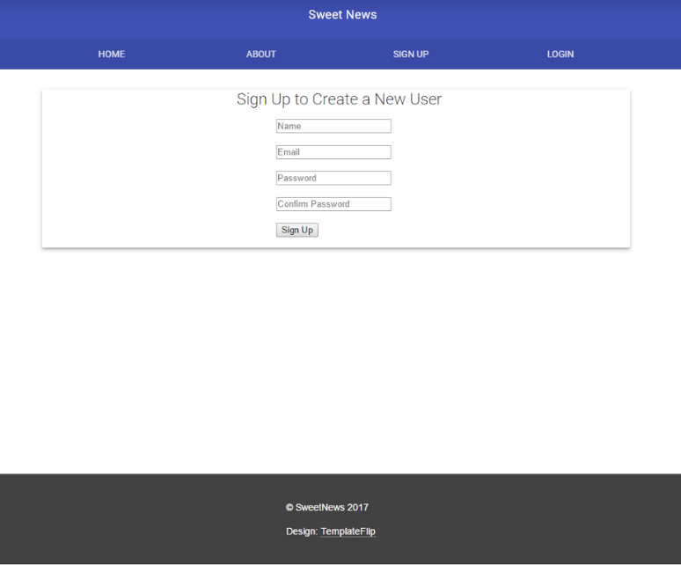

The Sign Up Page makes it possible for you to become a member of Sweet News by filling out the requested details and lets you enjoy the features provided to its members.

**User Preference Page**

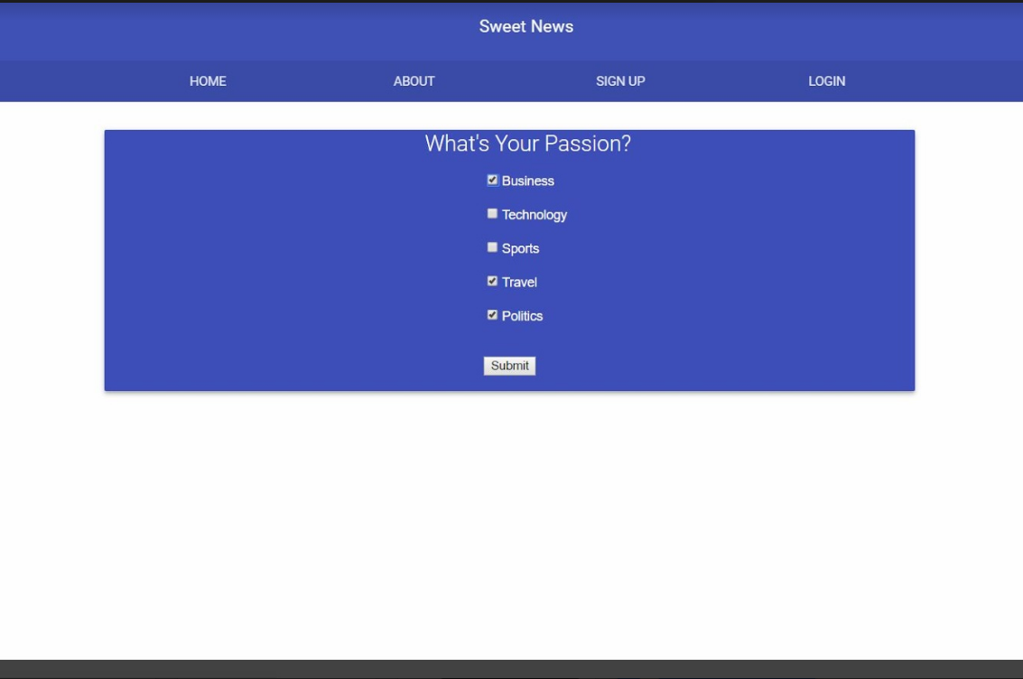

Once signed up, the user is directed to the User Preference page next. This page lets you customize your feeds based on your preference.

**Login Page**

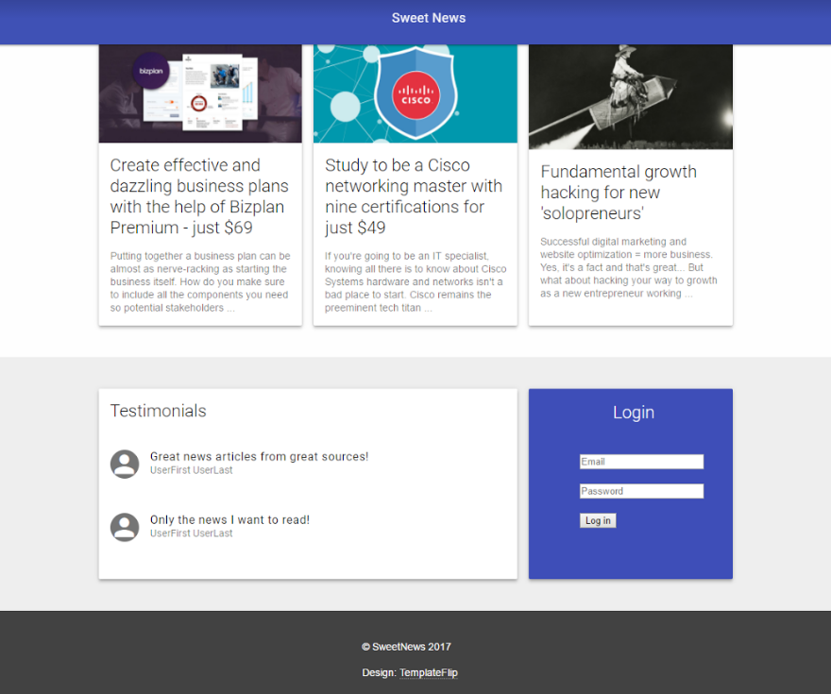

On clicking the Login option in the home page, you will be re-directed to the Login form located in the bottom of the same page. By providing the registered username and password you will be logged in. This enables you to view the news feeds in the home page customized to your preferences.

**Admin Page**

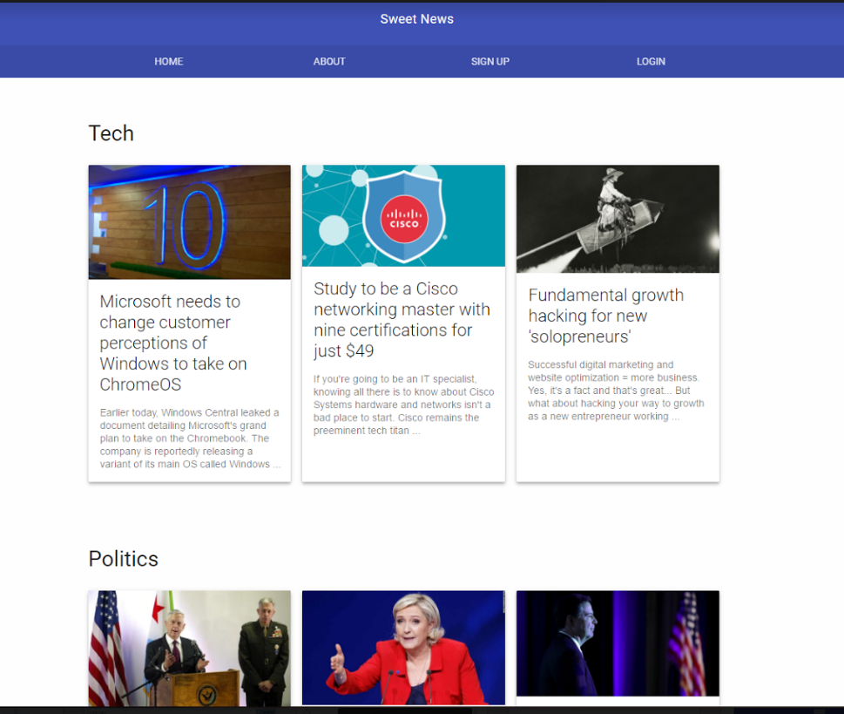

The Admin Page can be viewed only by Admin users. The Admin Users can “Add a new Source” and “Approve/Deny a Source.”

**Add a New Source**

Once logged in, the admin is directed to the Admin Main page. On the bottom of the admin page you will find the option to Add your Own Source. Add a source by providing the requested details.

The new source will appear in your feeds only if the admin approves the source request.

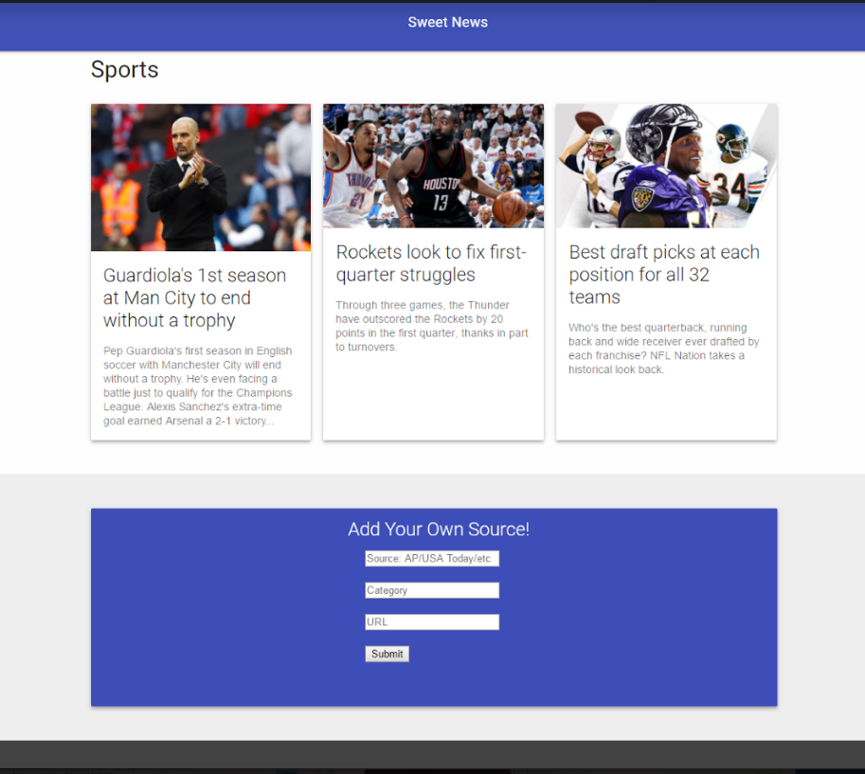

**Approve/Deny a Source**

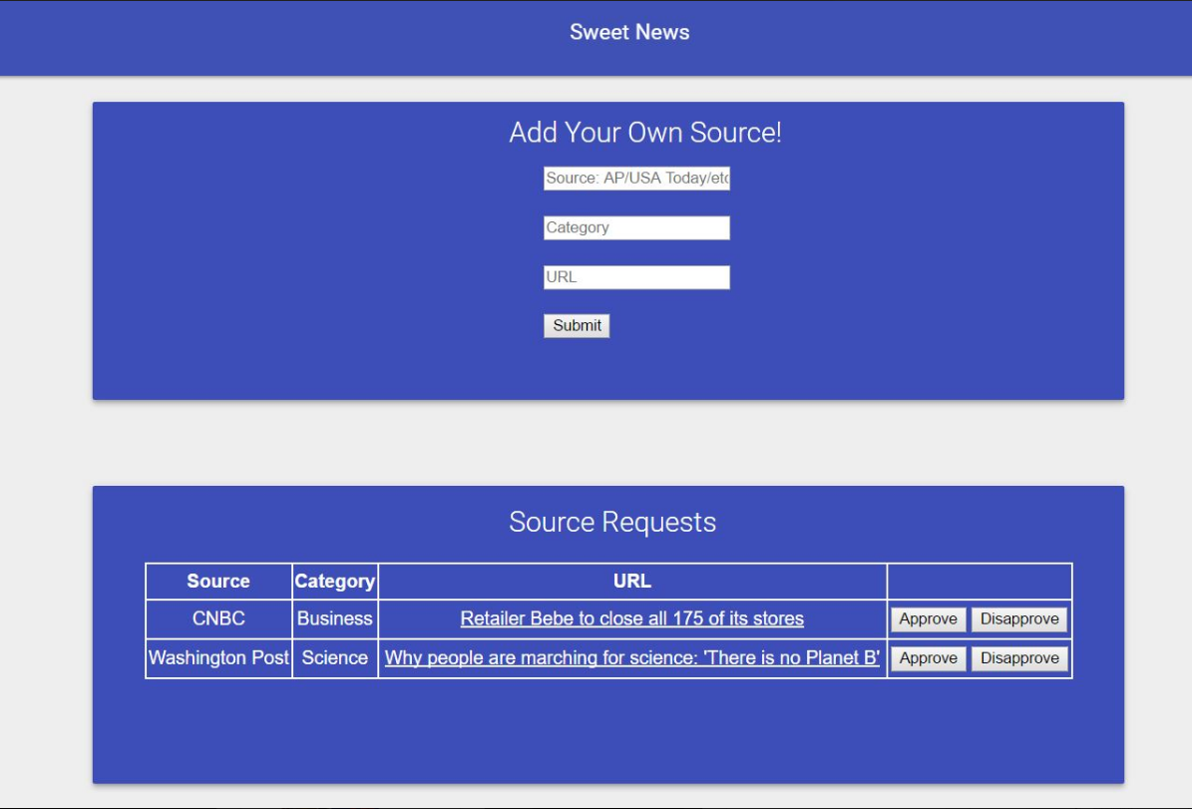

The option to Approve or Deny a source request helps to discard fake news in the site. The admin user only accepts a request with a credible source.

On the bottom of the admin page you will find a list of Source Requests that needs to be Approved or Denied. Once the credibility of the source has been determined, the admin can approve or deny the source by clicking on the Approve or Disapprove buttons respectively.